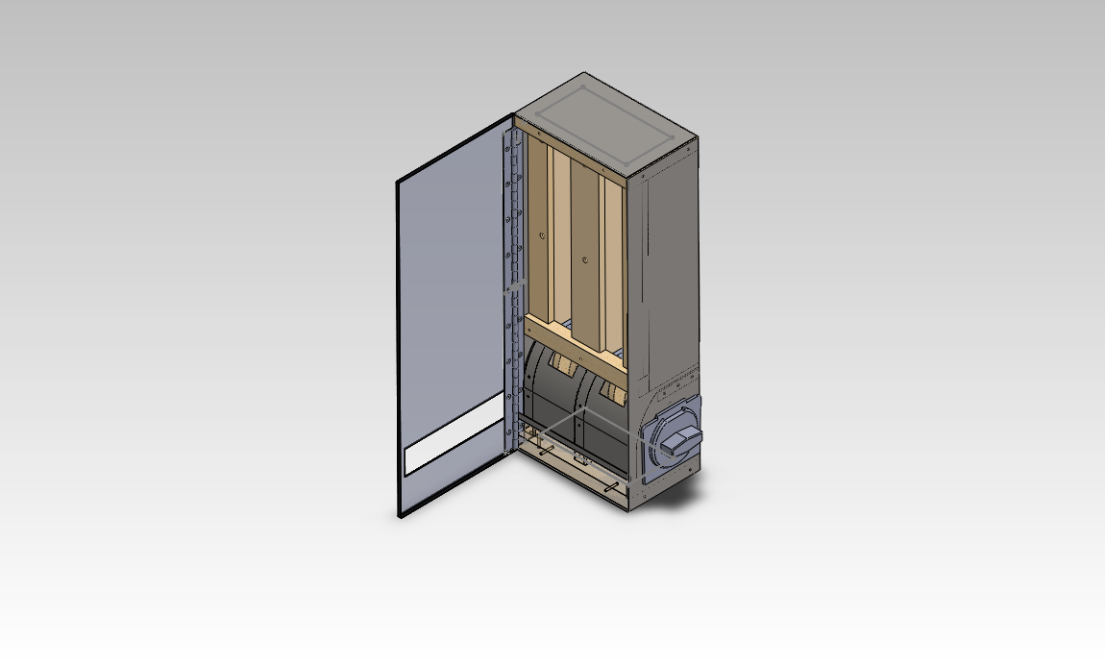Dragon v0.32

Instructions v0.1

**Parts Listing**

|  |  |  |  |
| --- | --- | --- | --- |
|  | PN001a – Inventory Interface Bar | Wood or Equivalent | 1 critical, 2 non-critical dimensions, 3 fastener locations |
|  | PN001b – Inventory Center Face | Wood or Equivalent | 2 critical, 1 non-crictial dimensions, 2 fastener locations |
|  | (2x) PN001c – Inventory Side Face | Wood or Equivalent | 2 critical, 1 non-critical dimensions, 2 fastener locations |
|  | (3x) PN002a –  Inventory Center Column | Wood or Equivalent | 2 critical, 1 semi-critical dimensions, 5 fastener locations |
|  | PN002b – Inventory Back Face | Wood or Equivalent | 2 critical, 1 semi-critical dimensions, 7 fastener locations |
|  | PN003 – Inventory Interface Plate | Steel, thick Aluminum, or Equivalent (Rigidity requirement) | All dimensions critical |
|  | PN004 – Axle | Aluminum or soft Steel (Rigidity + Crossdrill requirement) | Length critical, diameter variable w/ associated parts variable |
|  | PN005 – Large Gear | 3D printed currently, likely replicable from wood or similar | All dimensions critical |
|  | (4x) PN006 – Cam | Wood or equivalent | All dimensions critical (thickness semi-variable) |
|  | PN007 – Case | Thin gauge sheet steel or aluminum | All dimensions critical (folded sheet metal) |
|  | PN008 – Mechanism Guard | Thin gauge sheet steel or aluminum | All dimensions critical (folded sheet metal) |
|  | (2x) PN009 – Inventory Weights | Wood, Heavy chunk of metal, or other >500g mass | 2 dimensions semi-critical, 1 dimension minimized |
|  | (2x) PN010 – Axle Supports | Wood or equivalent | All dimensions critical |
|  | (2x) PN011 – End Caps | Wood or equivalent | 2 dimensions critical, 1 dimension variable |
|  | PN012 – Faceplate | Thin gauge sheet steel or aluminum | All dimensions critical (folded sheet metal) |
|  | PN013 – 18” Piano Hinge Section | Prepurchased, can be replaced with similar hinge mechanism | N/A – PN1569A227 |
|  | PN014 – Coin Mechanism Spacer | Wood or equivalent | All dimensions critical, thickness ~1mm tolerance |
|  | PN015 – Interface Plate Brace | Thin gauge sheet steel or aluminum, wooden block or equivalent may be substituted | 4 fastener positions |
|  | PN016 – Coin Mechanism | Purchased from Beaver Machine Corp. | <http://beavervending.com>  /coinmechs.asp |

|  |  |  |
| --- | --- | --- |
|  | (2x) Cotter Pins | May be substituted with screw, metal rod, etc.  Reference axle assembly section |
|  | (26x) 1 ½” Wood Screws | May be substituted with similar-length self-tapping flat (countersunk) head screws. |
|  | (18x) 1” security screws | Recommended for external, exposed-face screws to deter vandalism. |
|  | (2x) Camshafts | May be substituted with ~1 ½” long screw, dowel, or metal pin. Must secure to Cotter Pin in some fashion. |

**Hardware Listing**

Assembly Instructions

Section A: Inventory Assembly

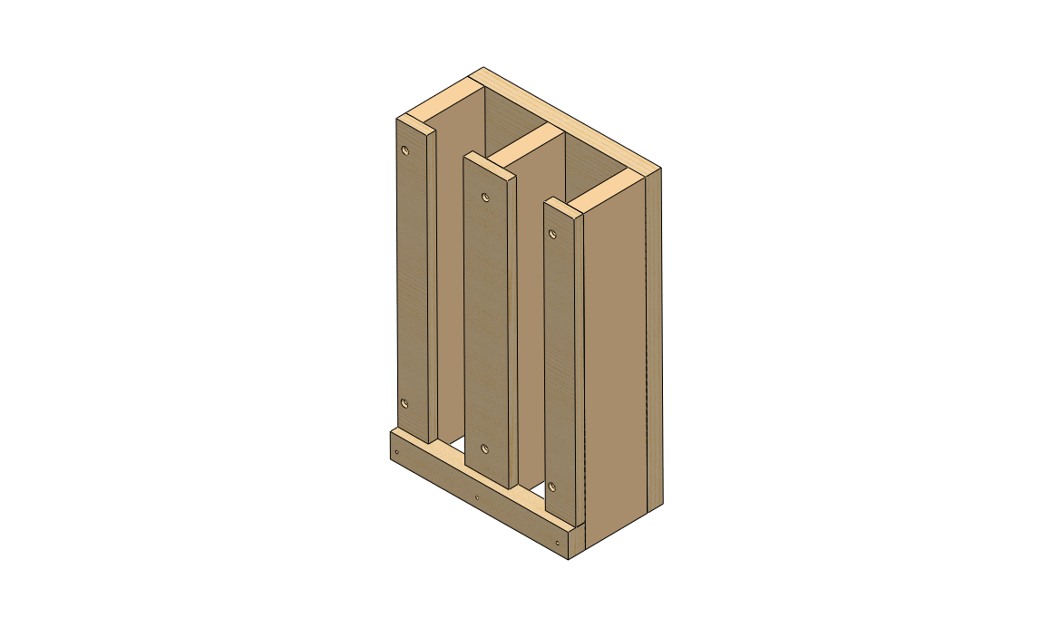

References: 0.3_PN001a.pdf

0.3_PN001b.pdf

0.3_PN001c.pdf

0.3_PN002a.pdf

0.3_PN002b.pdf

Materials: 1x PN001a

2x PN001b

1x PN001c

3x PN002a

1x PN002b

18x 1 ½” Wood Screws

Notes:

* When assembled, bottom face of inventory should be 2mm above Interface Plate. Failure to ensure proper spacing will prevent device from functioning as intended.
* Height measurements given are dependent on PN011 thickness, and may need to be adjusted to accommodate alternate PN011 (end cap) thicknesses.
* Internal chute dimensions must not make contact with any inventory, do not load inventory larger than device can vend. The device will jam if loaded with oversized inventory.
* If inventory is undersized >1/4” all sides, manufacture and insert PN002a spacers cut from appropriately thick material.

Procedure:

* Manufacture parts from wood according to blueprints.
  + (Recommended tools: Table saw, square, measuring equipment).
* Assemble 3x PN002a & 1x PN002b using 9x 1 ½” Wood Screws:

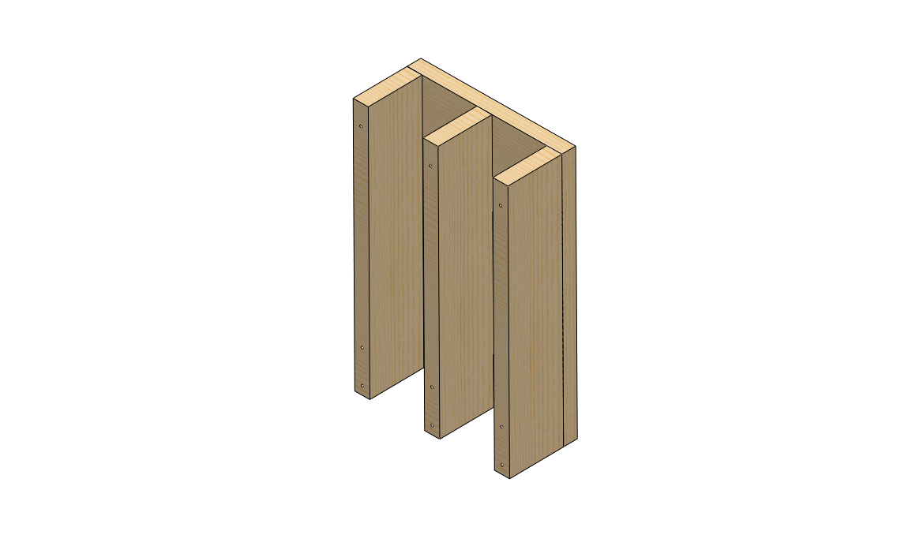

Procedure (Cont.):

* 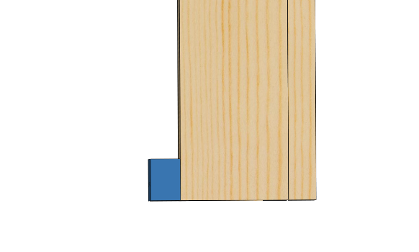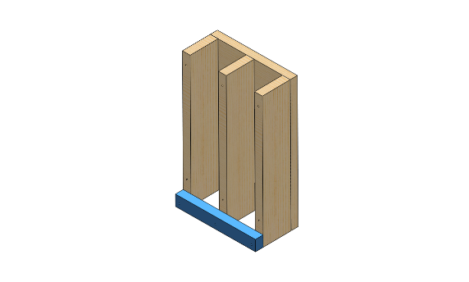Align PN001a flush with PN002 assembly, and secure with 3x 1 ½” Wood Screws:
* Align 2x PN002b, 1x PN002c with PN002 assembly, and secure with 6x 1 ½” Wood Screws:

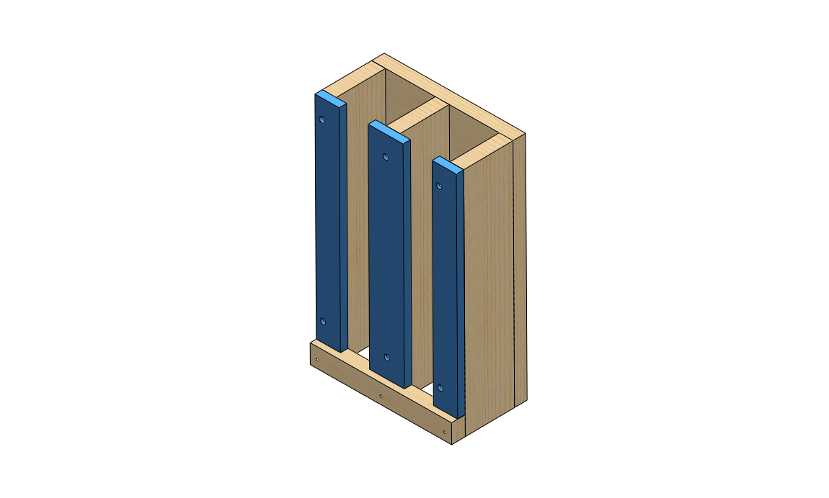

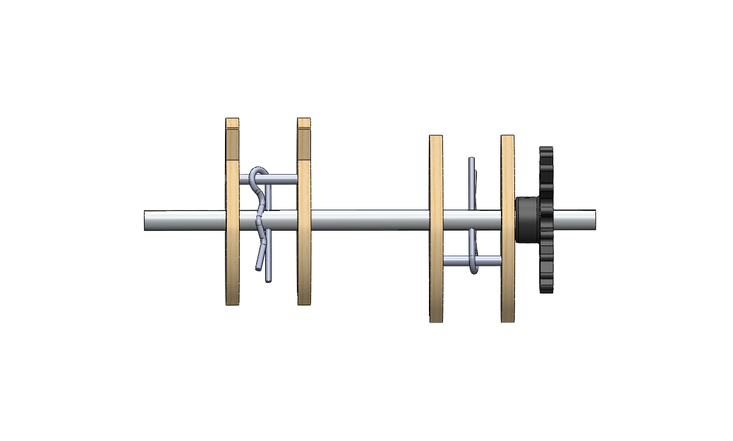Section B: Axle Assembly

References: 0.3_PN004.pdf

0.3_PN005.pdf

0.3_PN006.pdf

Materials: 1x PN004

1x PN005

4x PN006

2x Cotter Pins

2x Camshafts

1x PN005 mounting screw (small ~#4 screw)

Notes:

* Cam subassemblies may substitute machine screws, wooden dowels, or metal rods for Camshafts. Must be permanent assembly (cannot slide off)
* Other cam designs have been explored, reference earlier models and blueprints. Single cam designs give a high number of double vends and are inconsistent in comparison, but may be improved.
* Cotter Pins may be substituted as noted in parts list.
* Align Cotter Pin holes in PN004 with centers of inventory chutes, align gear with coin mechanism
* Ensure cams are offset exactly 180 degrees.

Procedure:

* Manufacture & Acquire components listed
* 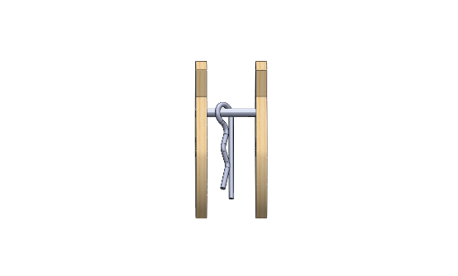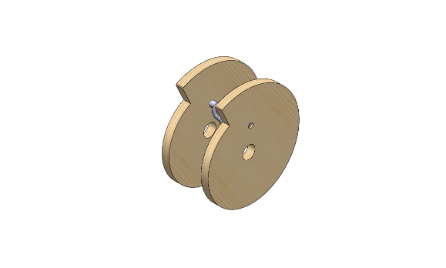Assemble Cam Subassemblies with 2x PN006 & 1x camshaft each:
* 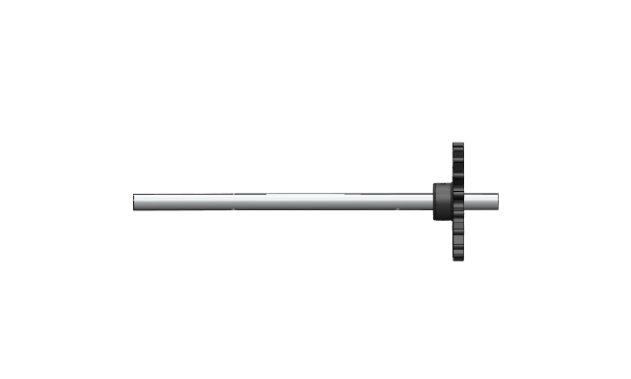Mount PN005 on PN004, using a cotter pin or small screw:
* 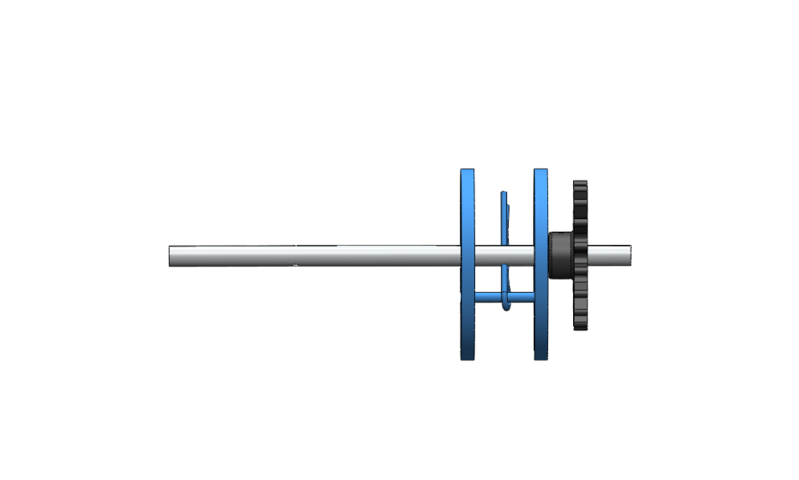Mount R cam assembly & secure, leave L cam assembly loose:
* Set aside and assembly Axle Mount Assembly.

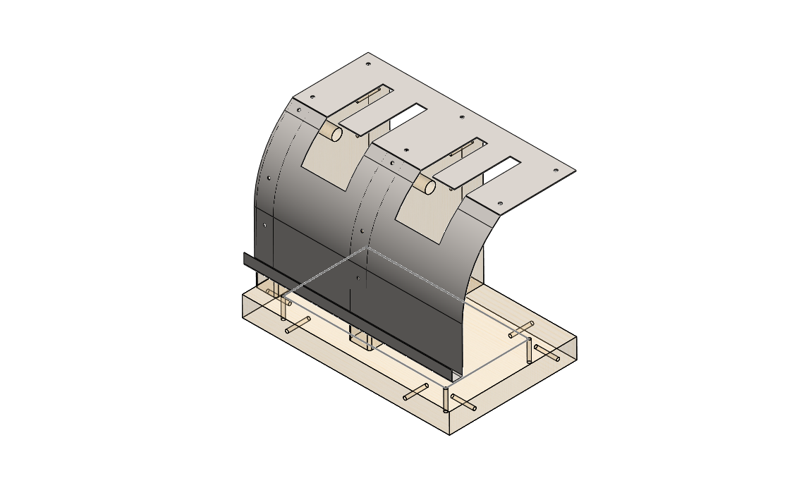Section C: Axle Mount Assembly

References: 0.3_PN003.pdf

0.3_PN008.pdf

0.3_PN010.pdf

0.3_PN011.pdf

Materials: 1x PN003

1x PN008

2x PN010

1x PN011

Notes:

* Axle location relative to coin mechanism, rear of inventory is critical. Ensure accurate location.
* Adjust height of PN010 if necessary to accommodate different PN011 thickness.
* PN003 flatness and rigidity is important, ensure part is free of burrs or damage.

Procedure:

* Attach 2x PN010 to PN011 with 4x Wood Screws as shown:
* 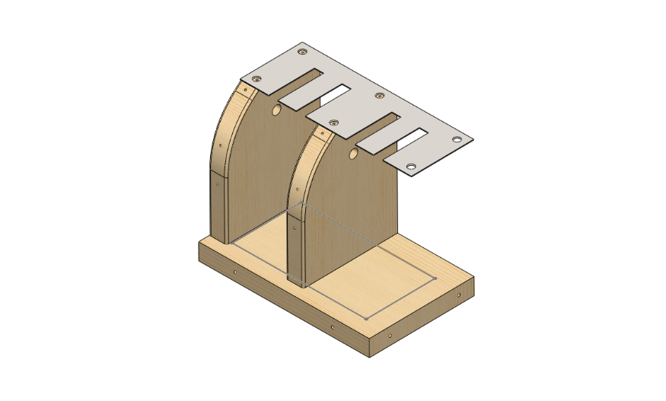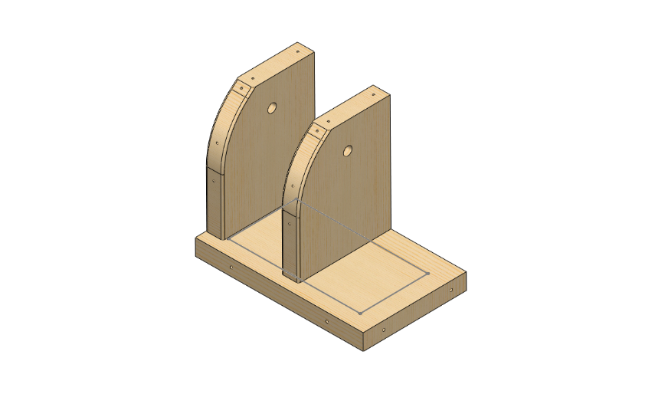Attach PN003 to top of PN010 with 4x Wood Screws as shown:
* 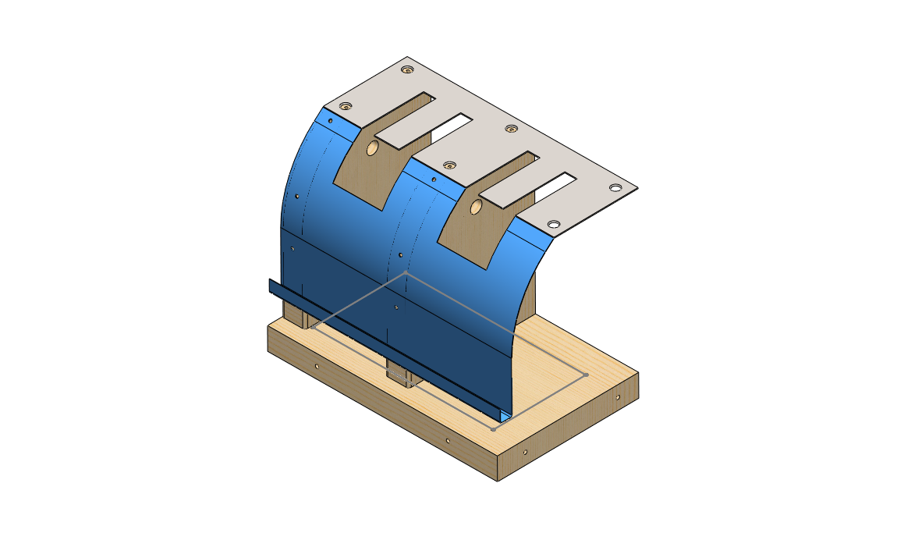Attach PN008 to face of assembly using 4x Wood Screws or panhead screws if available. Ensure PN008 upper edge is tucked under PN003, or else PN008 will catch inventory during vend and jam.
* 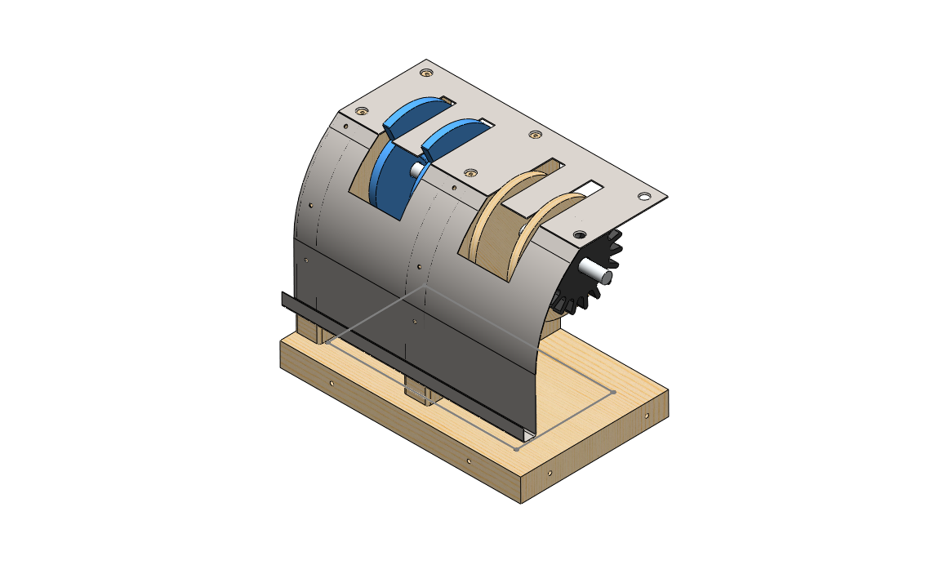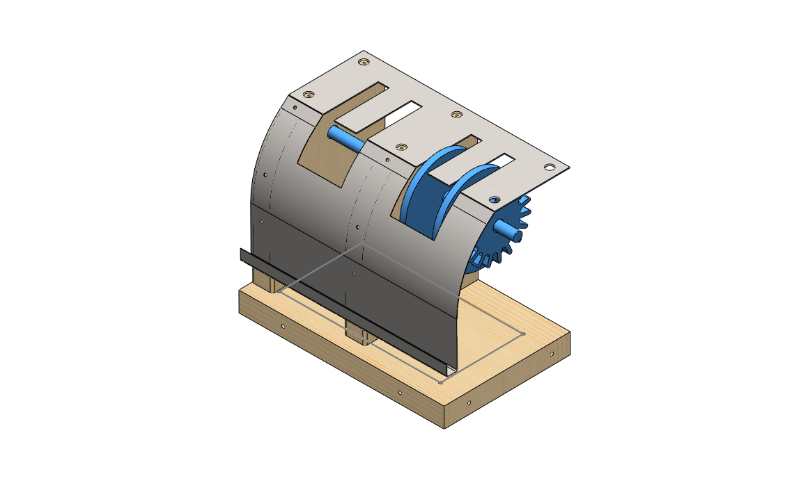Insert Axle assembly, and install second cam. Clip cam into place and check for free rotation. Ream PN010 axle mount homes further if rotation is restricted.

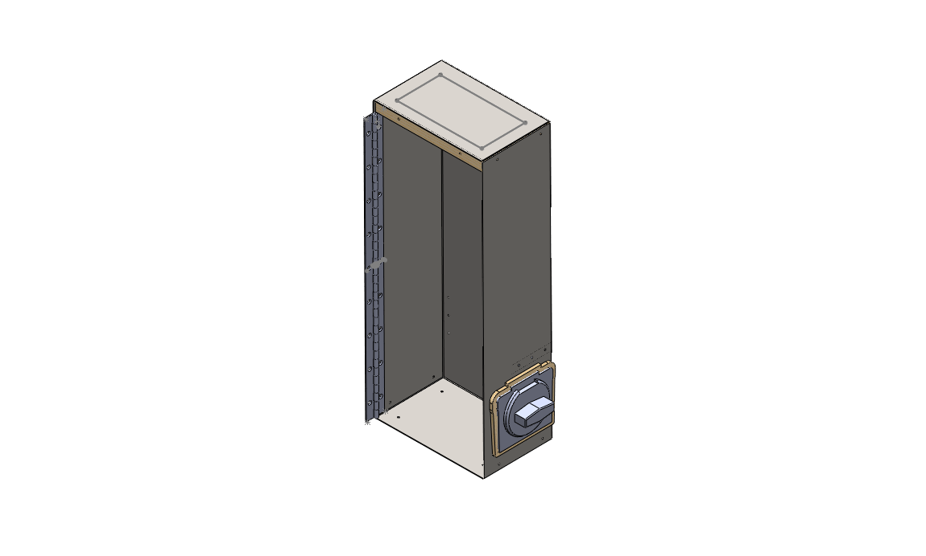Section D: Case Assembly

References: 0.3_PN007.pdf

0.3_PN011.pdf

0.3_PN014.pdf

Beaver Machine Co.

Materials: 1x PN007

1x PN011

1x PN014

1x PN015

1x Coin Mechanism

1x Hinge Section

10x Rivets for Hinge Section, PN015

Notes:

* Case flat pattern fits on 24”x36” sheet, with spare for PN008 & PN012
* Ensure case is square during assembly
* Cut coin mechanism opening carefully, use jigsaw or file as necessary
* Drill all holes before folding

Procedure:

* 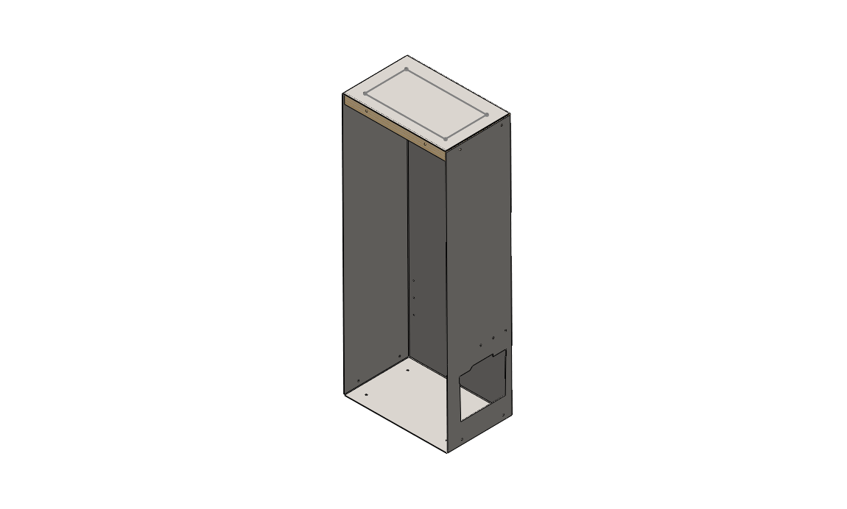Fold PN007 and secure with PN011, using security screws on upper and side faces.
* 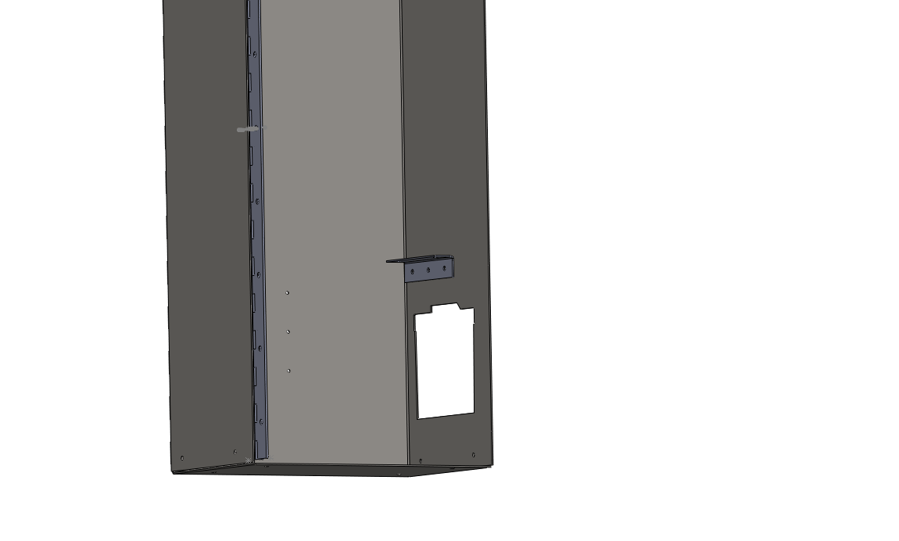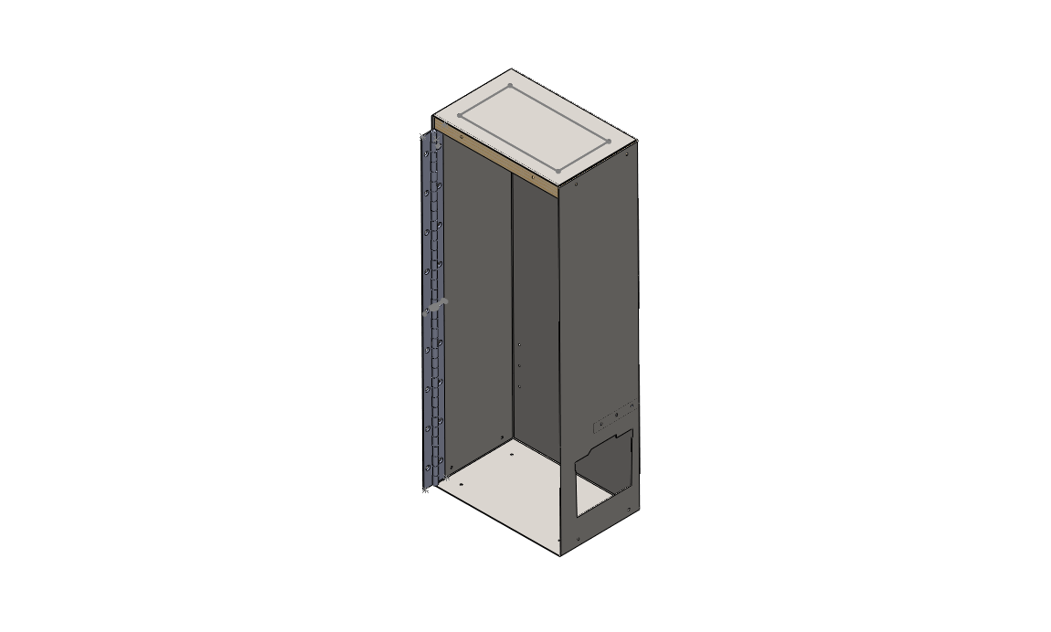Rivet Hinge Section, PN015 into place. Check PN015 location with Axle Assembly before fastening.
* Mount padlock hasp on PN007, if applicable. Typical mounting location is below Coin Mechanism, into lower end cap (PN011)
* 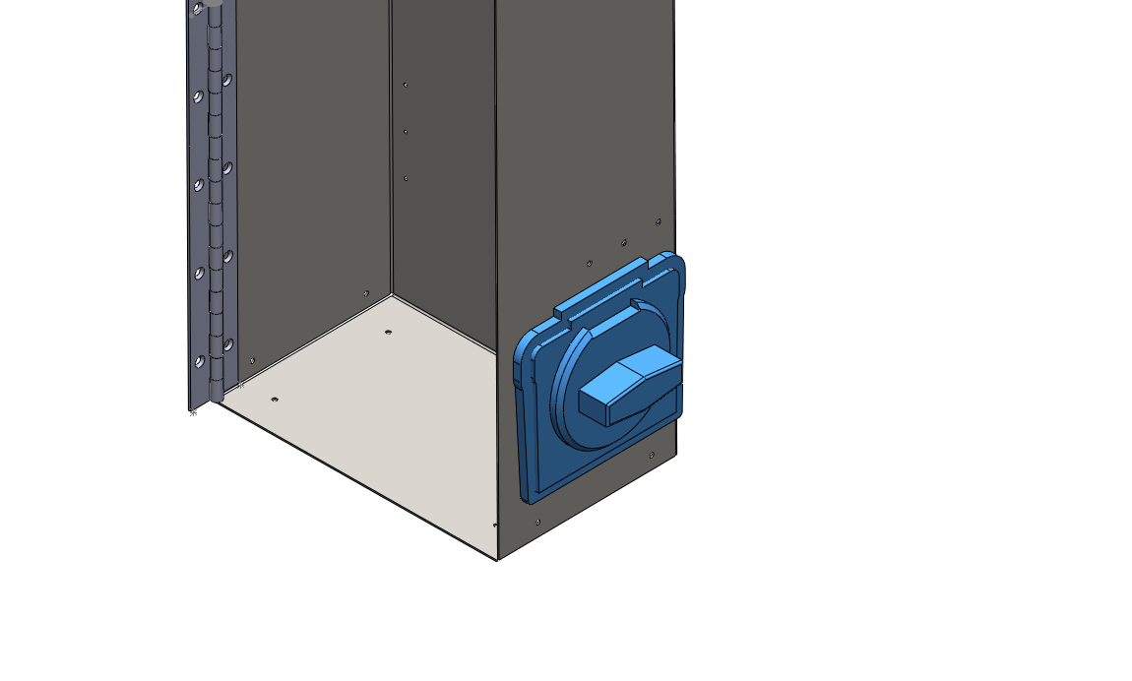Mount Coin Mechanism, reassembling by sandwiching PN007, PN014
* 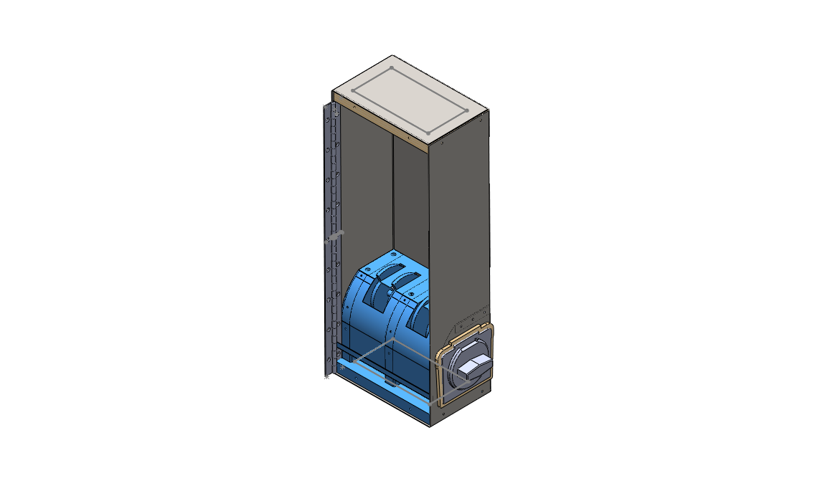Mount Axle Assembly in Case Assembly, and secure with 6x Wood Screws from reverse, 4x security screws on bottom, 4x security screws on sides.

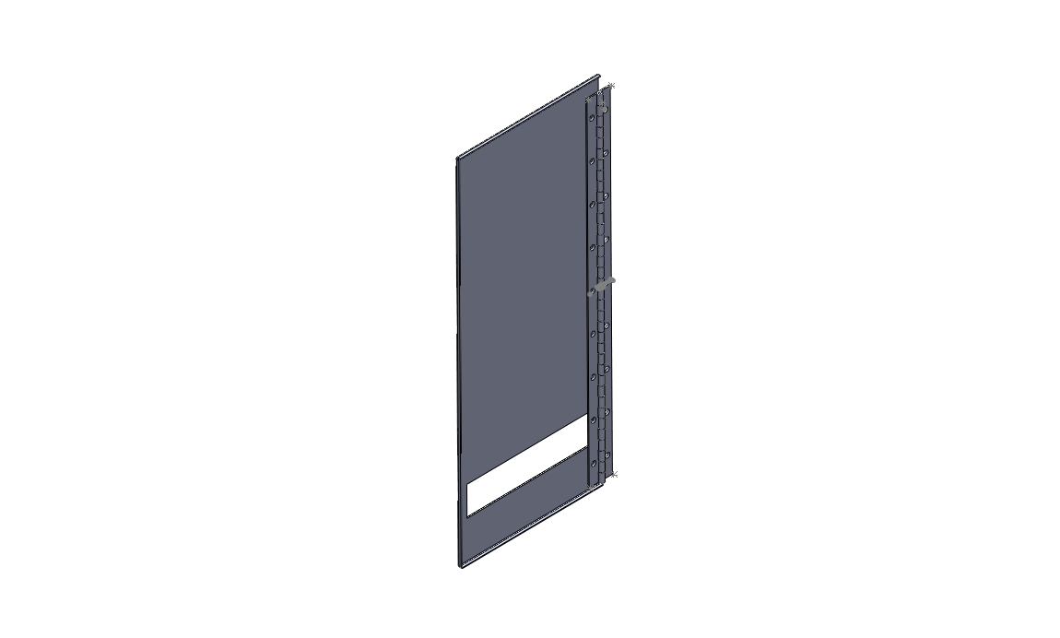Section E: Front Assembly, Final Assembly

Notes:

* Secure PN012 to Hinge and rest of case with rivets
* Attach padlock hasp if necessary. Typical mounting location immediately above bottom lip of lid.

